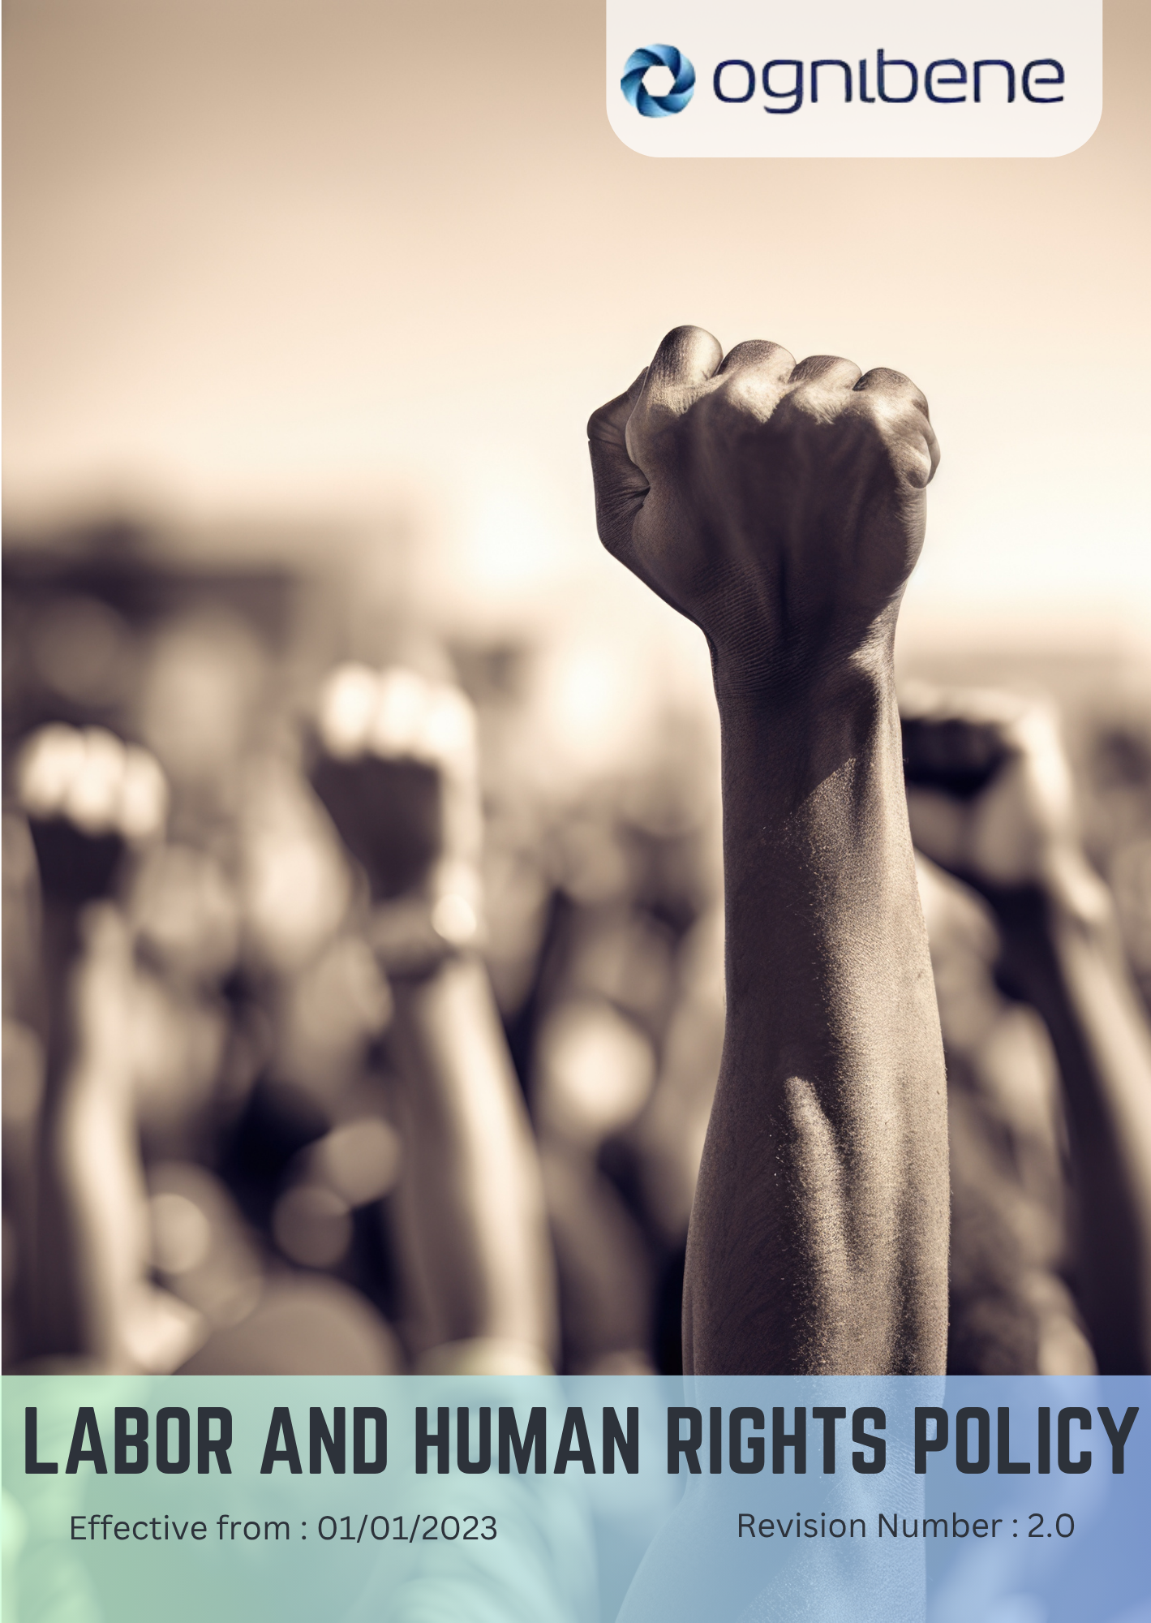

TABLE OF CONTENTS

Introduction 3
Scope 3
Policy Statement 3
Key Focus Areas 4
SDGs Covered 6
Responsibility 6
Review Mechanism 6
Revision History 7
Acknowledgement 8

Introduction
OGNIBENE INDIA PVT LTD, incorporated on February 10, 2006, is dedicated to designing and manufacturing hydraulic cylinders and hydraulic steering systems for off-highway vehicles, automotive, and marine applications. We are committed to upholding the highest standards of labor rights and human rights. We believe that every employee deserves a safe, equitable, and inclusive work environment. Our policy outlines our commitments to address critical areas of labor rights and human rights within our operations.

Scope
This policy applies to all workers, employees, directors, officers, agents, contractors, and any third parties acting on behalf of OGNIBENE INDIA PVT LTD. It covers all business activities, including procurement, sales, marketing, and any interactions with government officials, customers, suppliers, and other stakeholders. The policy is applicable globally, regardless of local business practices or cultural norms. This policy applies to below mentioned locations:
Unit 1: | Ognibene India Private Limited – Pune Plant (I)  Plot A-13 Talegaon MIDC Village Ambi Navlakh Umbhre Talegaon, Pune Maharashtra – India
Unit 2: | Ognibene India Pvt. Ltd.  Unit No. A, B-600, Plot No.8, Ishanvi Industrial & Logistics 140402 Park, Vividha Ind. Park, Chamaru, Rajpura Patiala – Punjab – India

Policy Statement
OGNIBENE INDIA PVT LTD is dedicated to fostering a workplace that respects labor rights and human rights. We are committed to providing a safe and healthy work environment, ensuring fair working conditions, promoting structured social dialogue, and supporting diversity, equity, and inclusion. We actively prevent child labor, forced labor, and human trafficking in our operations and supply chain.

Key Focus Areas
Below are our commitments and targets towards environmental sustainability as compared to baseline year 2023.

- Employee Health & Safety
Commitment: To ensure safety at work through comprehensive health and safety programs, aiming to maintain workplace accidents by 0% by 2030 and maintain a 95% employee satisfaction rate regarding health and safety measures. By implementing advanced safety training, hazard monitoring systems, and regular emergency drills, we target zero fatal incidents and achieve 100% compliance with safety standards by 2030.
- Working Conditions
Commitment: To promote work-life balance and fair working conditions, targeting an 88% satisfaction rate in employee surveys by 2030. By implementing flexible scheduling, improved workplace ergonomics, and enhanced rest and welfare facilities, we achieve a 30% improvement in employee retention and reduce absenteeism by 20% by 2030.

- Social Dialogue
Commitment: To facilitate structured social dialogue through recognized employee representatives, ensuring at least 80% of employee concerns are addressed within one year by 2030. By conducting quarterly meetings, publishing feedback summaries, and tracking resolutions, we achieve 100% employee participation in dialogue programs and strengthen trust by 2030.

- Career Management & Training
Commitment: To support employees in career development by providing a minimum of 25 hours of training per employee annually and achieving a 30% internal promotion rate for eligible positions by 2030. By introducing leadership development programs and e-learning modules, we improve average employee skill index by 35% and increase training satisfaction by 25% by 2030.

- Discrimination & Harassment
Commitment: To maintain a workplace that is free from any form of discrimination, harassment, or retaliation, ensuring every employee is treated with dignity and respect, we aim to achieve zero confirmed cases of discrimination or harassment by 2030. By implementing awareness campaigns and mandatory anti-harassment training, we ensure 100% employees gain knowledge about these issues. We are committed to addressing 100% of reported cases within 30 days and ensuring that all managers complete annual sensitivity training by 2030.

- Child Labor, Forced Labor & Human Trafficking
Commitment: To strictly prohibit child labor, forced labor, or human trafficking, committing to 100% compliance through annual audits and zero reported incidents by 2030. By establishing supplier monitoring systems and whistleblower protection mechanisms, we ensure 100% vendor compliance and provide annual awareness training to all employees by 2030.

- Diversity, Equity, and Inclusion
Commitment: To create an inclusive workplace free from discrimination, harassment, or abuse, targeting a 20% increase in workforce diversity by 2030 and a 95% employee satisfaction rate regarding inclusion initiatives. By implementing gender equity initiatives, awareness programs, and mentorship opportunities, we achieve 100% pay equity across all levels and zero discrimination complaints by 2030.

- Human Rights in Community Engagement

Commitment: To address both direct and indirect human rights impacts of the company’s operations on external stakeholders, committing to 100% compliance with human rights due diligence by 2030, and to ensure zero reported violations of stakeholder human rights through annual assessments.

- Living Wage
Commitment: To ensure all employees receive a living wage that meets basic needs, we are targeting to maintain we target 100% compliance by 2030. By reviewing wage structures and linking annual increments to cost-of-living indices, we ensure zero pay gap across all employee categories by 2030

- Mental Health Support
Commitment: To promote mental well-being by offering mental health resources and training, aiming for a 70% participation rate in mental health programs among employees by 2030.

- Supplier Labor Standards
Commitment: To ensure suppliers adhere to labor rights standards by conducting audits on 100% of key suppliers by 2030 to verify compliance.

SDGs Covered
OGNIBENE INDIA PVT LTD is committed to achieve the following Sustainable Development Goals:
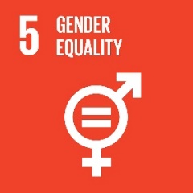

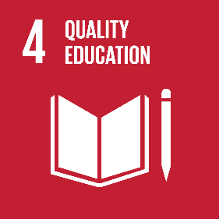
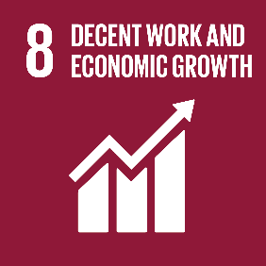
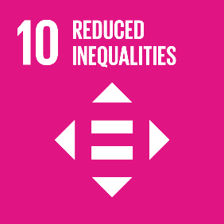


Responsibility
The implementation and compliance of this Labor & Human Rights Policy are overseen by HR Manager and the Compliance Officer at OGNIBENE INDIA PVT LTD. The HR Manager is responsible for ensuring that all employees understand their rights and responsibilities, developing training programs, and monitoring the effectiveness of these initiatives. Meanwhile, the Compliance Officer ensures adherence to labor and human rights regulations by conducting regular audits and identifying areas for improvement. Together, they foster a culture of accountability and transparency to uphold labor and human rights within the organization.

Review Mechanism
This Labor & Human Rights Policy will be conducted every two years by the HR Manager and the Compliance Officer to ensure its relevance and effectiveness. They will assess the implementation of the policy, gather feedback from employees, and make necessary updates based on evolving best practices in labor and human rights. The HR Manager will lead the review process, while the Compliance Officer will provide insights on regulatory changes and compliance issues to ensure ongoing alignment with legal requirements.

Revision History
Revision No. | Date | Description of Changes | Approved By
0.0 | 01 Jan 2023 | Initial Policy Draft | General Manager Operations
1.0 | 01 Jan 2024 | Updated Scope and add the Acknowledgement section | General Manager Operations
2.0 | 01 Jan 2025 | Updated Key Focus Areas revised with action-oriented commitments, added “Discrimination & Harassment” sub-topic, and introduced the Revision History table | General Manager Operations

Approved by: General Manager of Operations
Last Review Date: 01 JAN 2025 Next Review Date: 01 JAN 2027

Acknowledgement
I, _________________________, acknowledge that I have read, understood, and agree to adhere to the company’s Labor & Human Rights Policy. I recognize the importance of my role in supporting the company's commitment to fair labor practices and am committed to actively participating in the implementation of this policy. I will strive to incorporate ethically responsible practices into my daily work activities, comply with all relevant labor regulations and company policies, and support the continuous improvement of our labor practices.

I understand that my commitment is essential to achieving the company's objectives and fostering a culture of a secure and respectful workplace. I am dedicated to contributing to our shared vision of fair and ethical business practices.

Employee Name:
Employee Signature:

